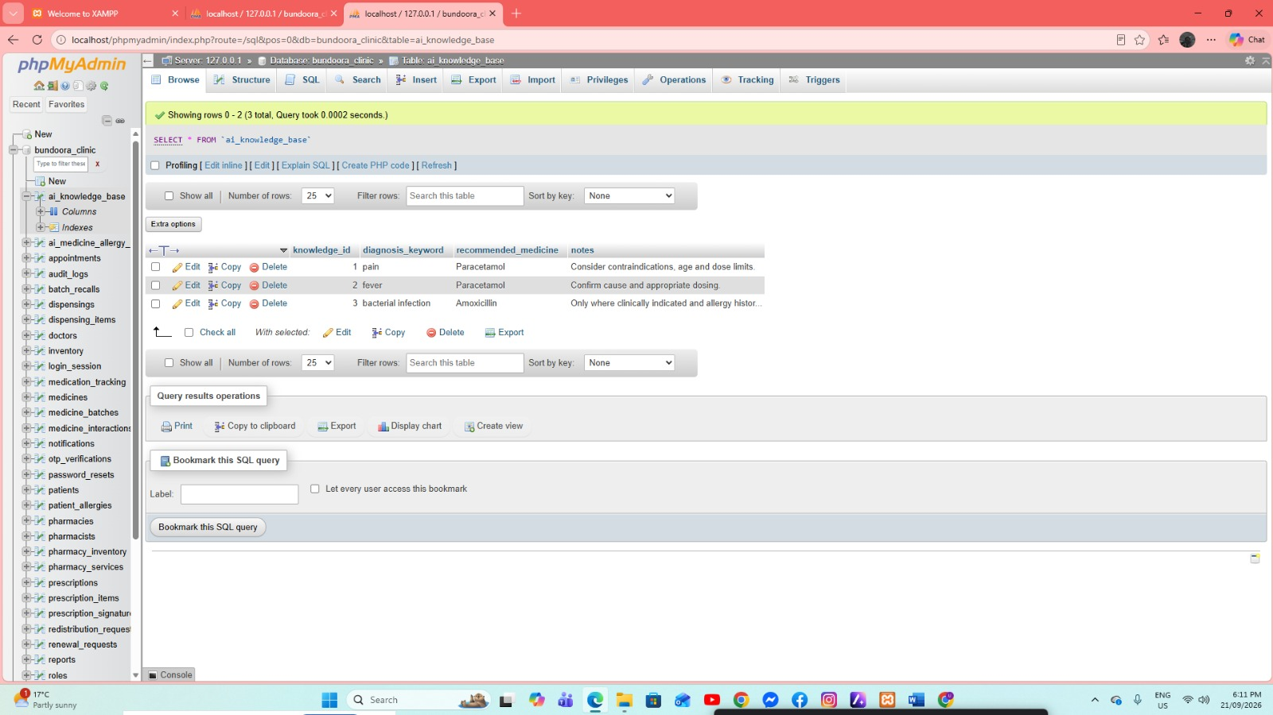
Shows the ai_knowledge_base table in phpMyAdmin, where diagnosis keywords are linked with recommended medicines and supporting notes. This view demonstrates how the system stores structured information used by the clinic's AI-assisted recommendation component.
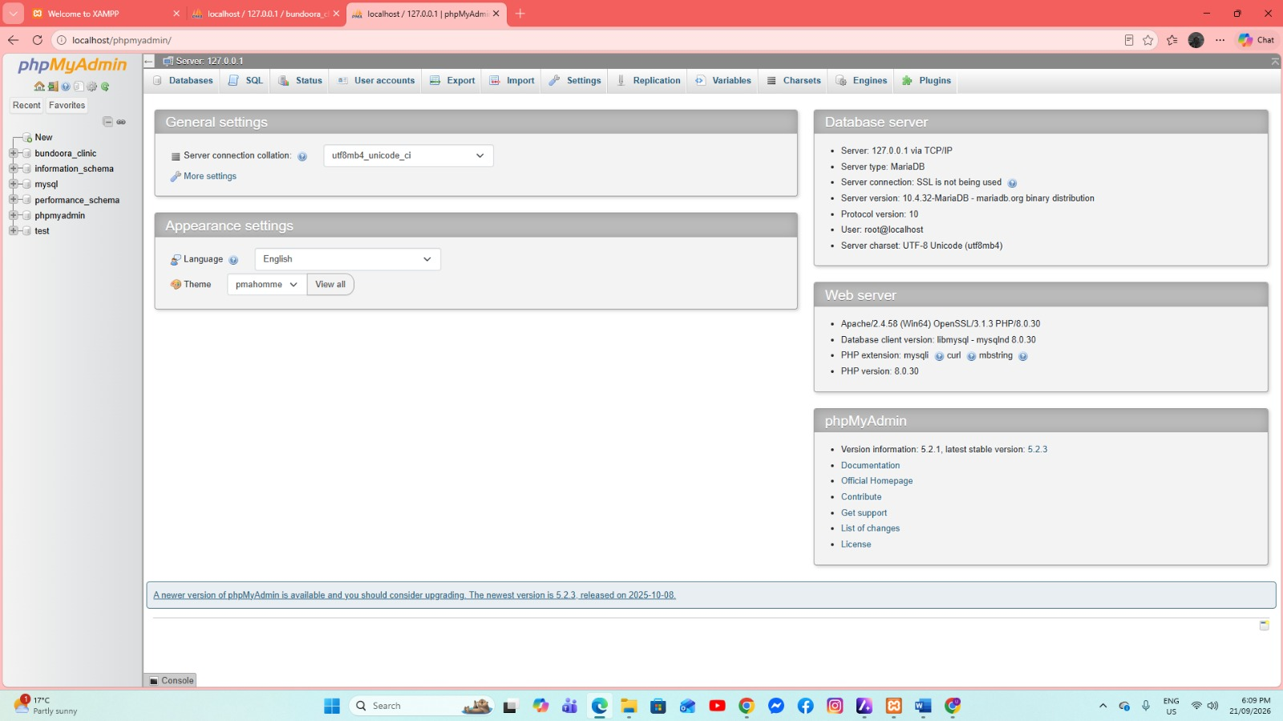
Shows the phpMyAdmin environment connected to the local MariaDB server at 127.0.0.1. It confirms that the database administration interface and PHP environment are available for managing the Bundoora Family Clinic database.
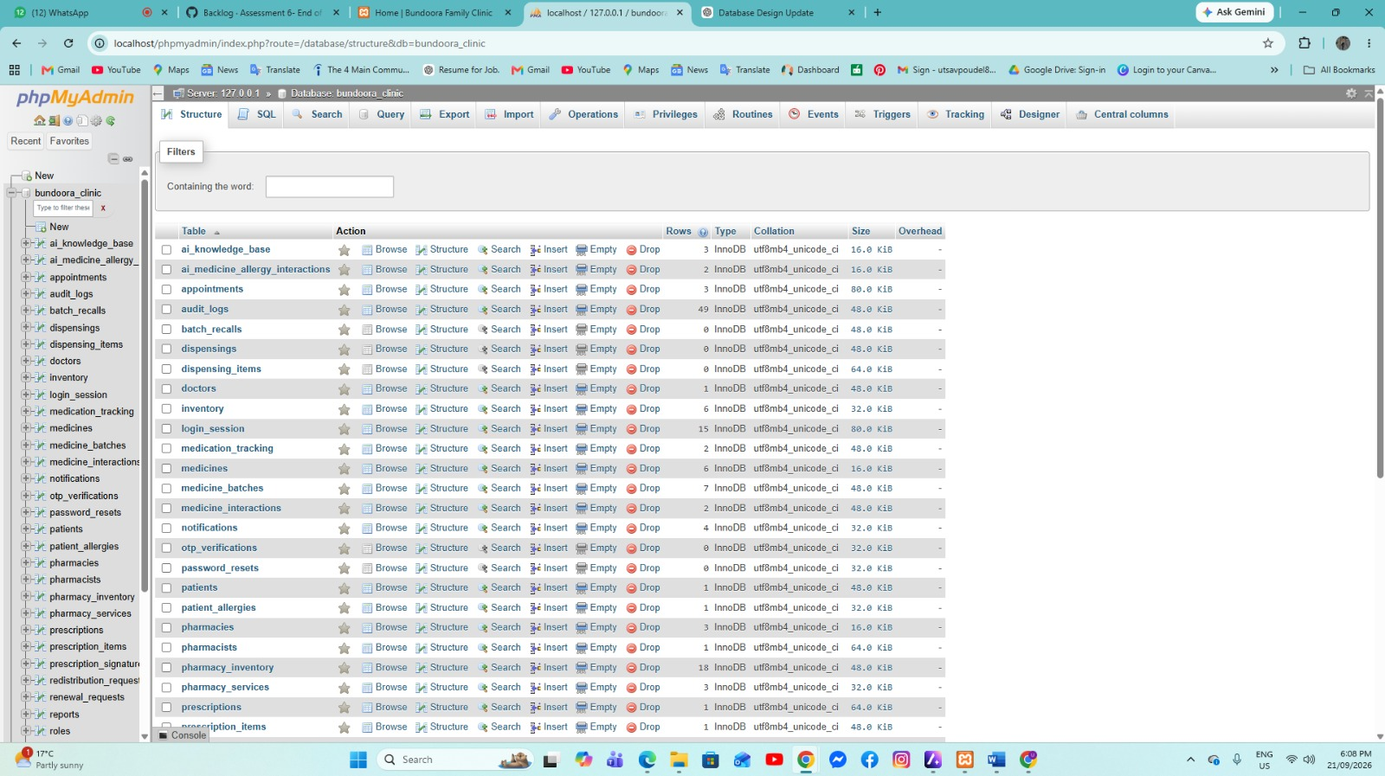
Displays the Bundoora Clinic database structure in phpMyAdmin, including the tables used for clinical records, pharmacy operations, inventory, security, prescriptions, and system functions. This provides an overview of the database components currently created in the system.
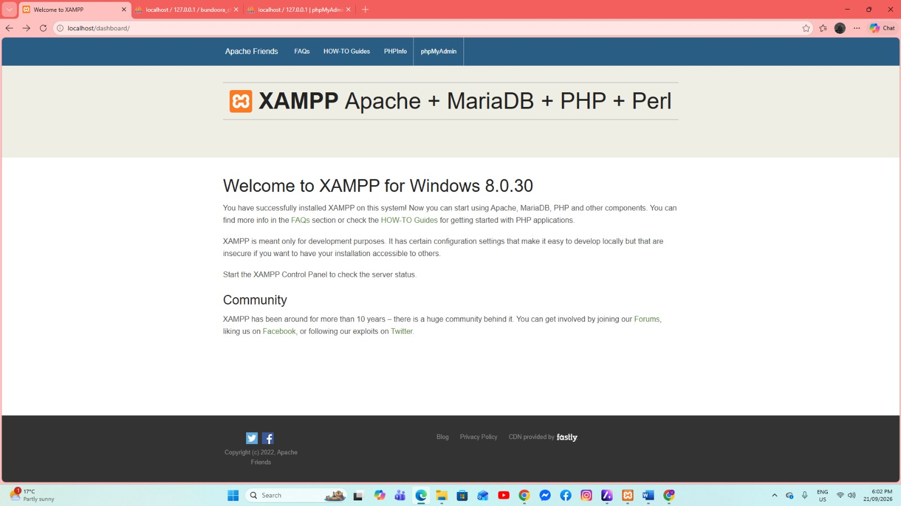
Confirms that the local XAMPP environment is installed and accessible through localhost. XAMPP provides the Apache web server, MariaDB database server, PHP, and related components used to run the Bundoora Family Clinic system locally.
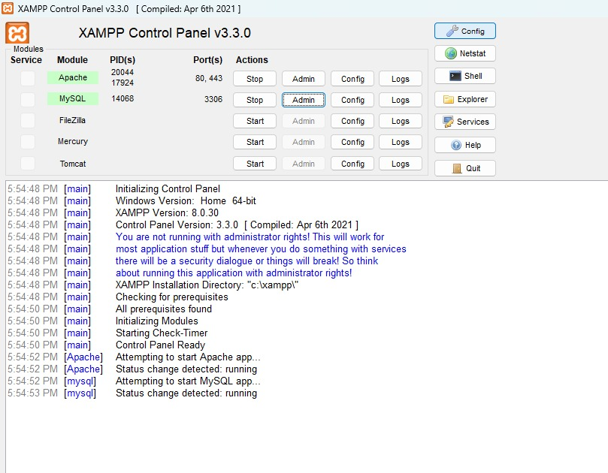
Shows the XAMPP Control Panel with Apache and MySQL running successfully. These active services provide the local web server and database connection required for the clinic application to operate.
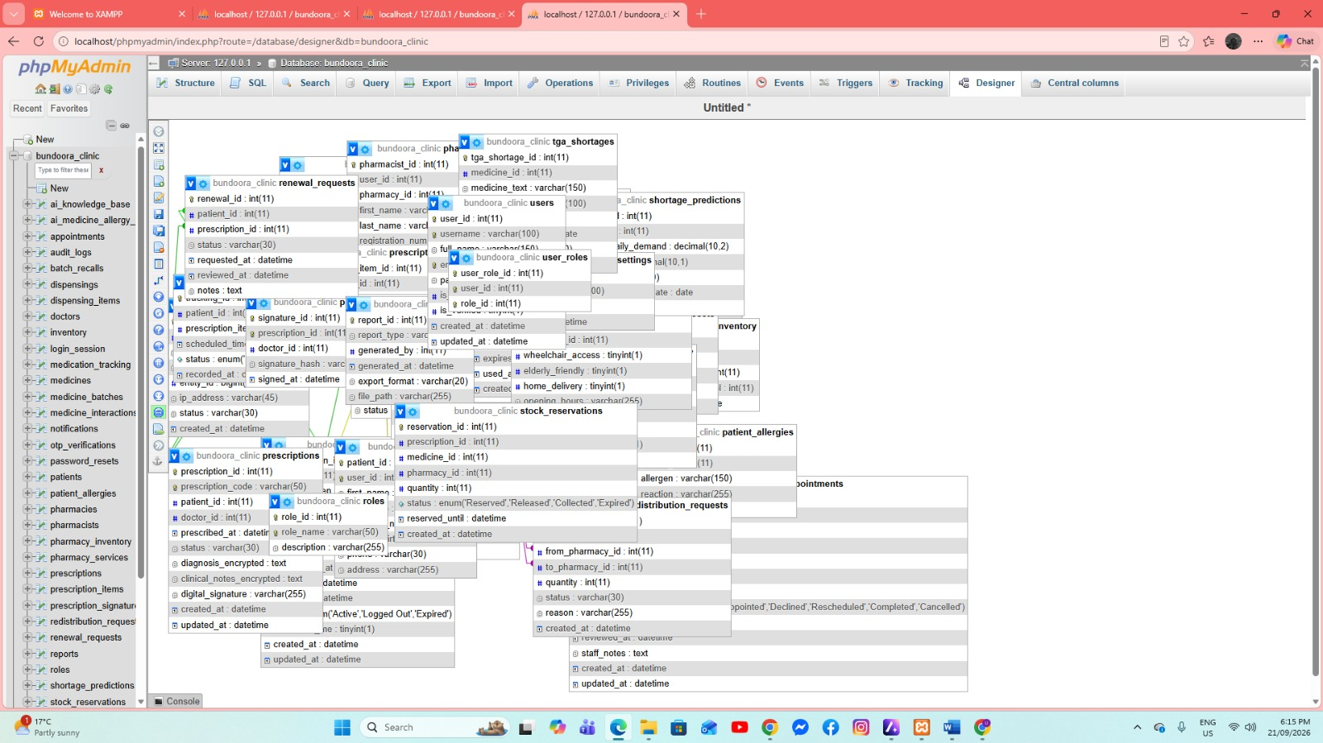
Displays the phpMyAdmin Designer view of the Bundoora Clinic database. The diagram gives a visual overview of the database tables and their relationships, showing how users, roles, prescriptions, pharmacies, stock, and other system records are connected.

The Bundoora Family Clinic database is a centralized clinical, pharmacy, security, and inventory management system designed to connect users, doctors, patients, pharmacists, prescriptions, medicine stock, and pharmacy operations within one relational workflow.
Its architecture is organized around four core pillars:
User Management & Clinical Roles: A unified users and roles layer supports Administrator, Doctor, Patient, and Pharmacist access, with dedicated doctor, patient, and pharmacist profiles plus OTP verification, password recovery, active login-session tracking, and audit logging.
Consultations & Digital Prescribing: Appointments connect patients and doctors, while prescriptions, prescription items, prescription signatures, renewal requests, stock reservations, dispensing records, and medication tracking support the prescription lifecycle from consultation through collection and adherence.
AI-Assisted Decision Support & Safety: The knowledge base provides medicine recommendations from diagnosis keywords, while medicine-interaction and patient-allergy tables provide structured safety information that can be checked during prescribing and dispensing.
Pharmacy Logistics, Inventory & Compliance: Medicine, batch, central inventory, pharmacy inventory, pharmacy service, shortage prediction, TGA shortage, redistribution, recall, notification, and reporting structures support branch stock visibility, batch traceability, shortage monitoring, and operational control.
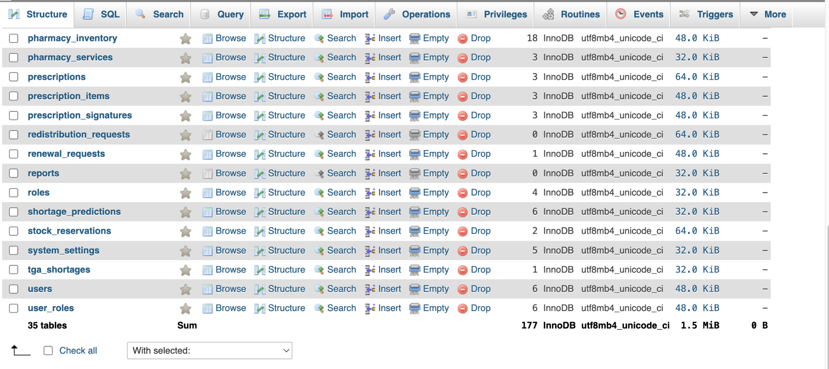

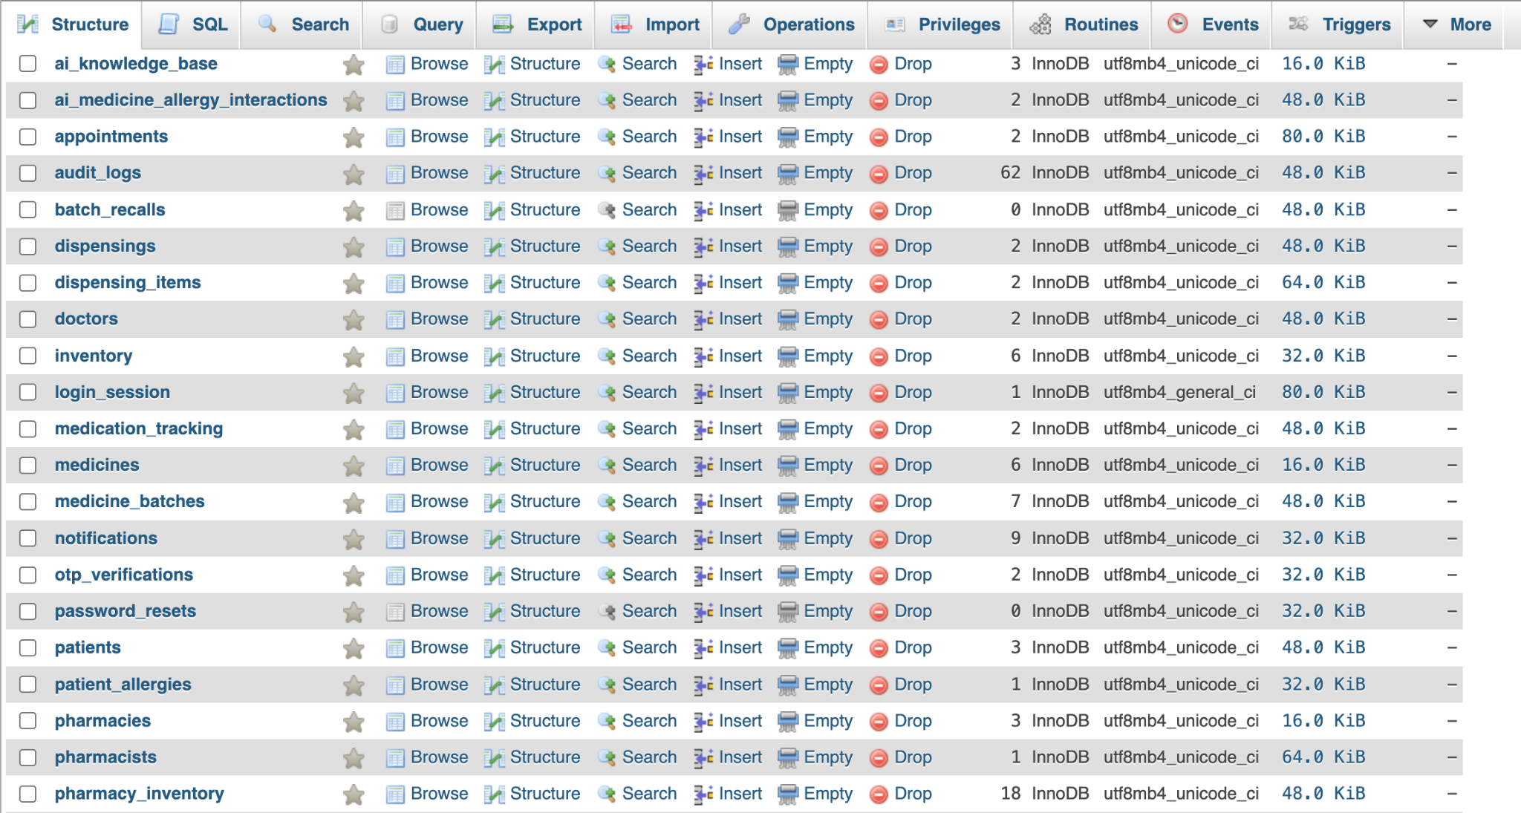
The phpMyAdmin structure view confirms a 35-table InnoDB database. The supplied structure screenshots show 177 rows in total across the current dataset and use utf8mb4 collations. The tables are separated by responsibility, with identity and access, clinical records, pharmacy stock, prescribing, dispensing, safety, notifications, forecasting, and system configuration maintained in dedicated relational structures.

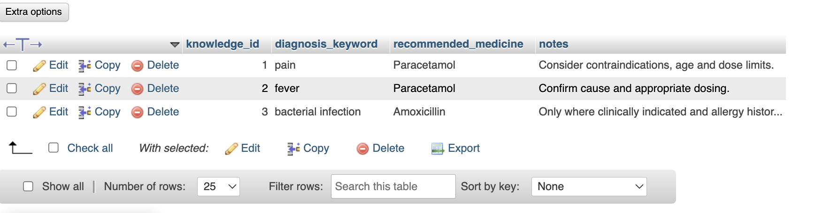
Functions as a clinical recommendation knowledge table. It stores a knowledge_id for each rule, a diagnosis_keyword such as pain, fever, or bacterial infection, the recommended_medicine text, and supporting notes. The visible examples recommend Paracetamol for pain and fever and Amoxicillin for bacterial infection, while the notes remind the application or clinician to consider contraindications, age, dose limits, cause, allergy history, and whether treatment is clinically indicated.

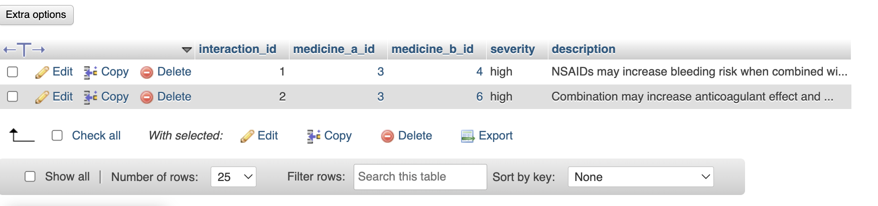
Acts as a medicine interaction safety registry. Each interaction record links two medicines through medicine_a_id and medicine_b_id, assigns a severity level, and stores a human-readable description of the risk. The visible records are marked high severity and describe increased bleeding or anticoagulant effects. This structure gives the application a direct source for warning users when two medicines in the same treatment plan may require additional clinical review.

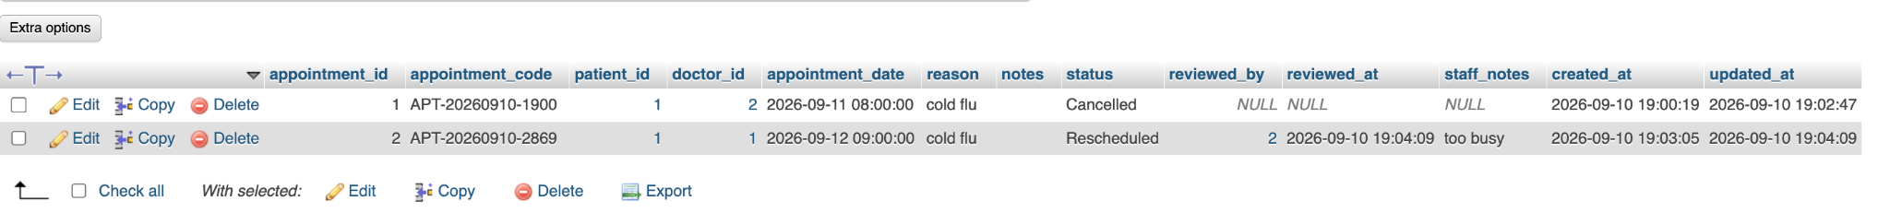
Manages appointments between patients and doctors. Each row has an appointment_id and appointment_code and links a patient_id with a doctor_id at an appointment_date. The record also stores the reason, notes, current status, review details through reviewed_by and reviewed_at, optional staff_notes, and created/updated timestamps. The sample data demonstrates appointment lifecycle handling, including a cancelled booking and another booking that was rescheduled after staff review.

Provides a system activity audit trail. The audit_logs table records the acting user_id, the action performed, the entity_type and entity_id affected, the originating ip_address, the outcome status, and the created_at timestamp. The visible examples include a successful login and a successful user update. These records support accountability by showing who performed an operation, what type of record was involved, where the request originated, and whether the operation succeeded.

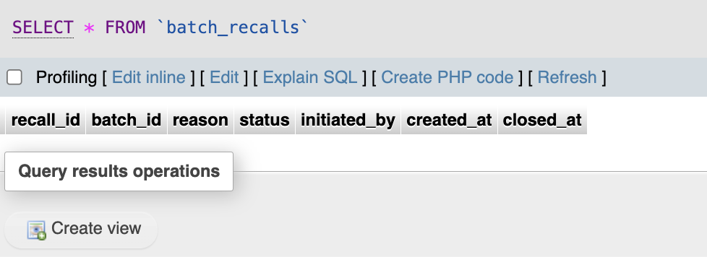
Supports medicine batch recall management. Its fields include recall_id, batch_id, reason, status, initiated_by, created_at, and closed_at, allowing a recall to be opened against a specific medicine batch, assigned a reason, tracked through a status, and closed when resolved. The supplied screenshot currently shows no recall records, but the table structure is present for documenting and controlling recalled or otherwise unsafe stock at batch level.

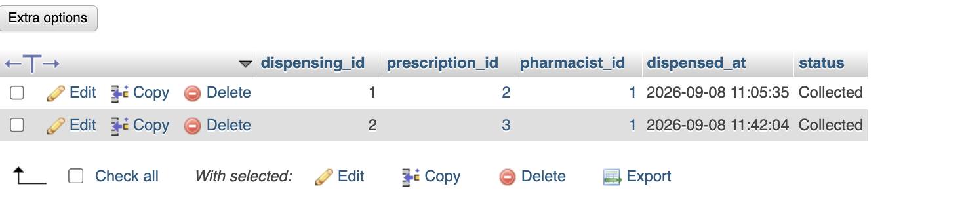
Records completed or in-progress prescription dispensing events. Each dispensing has a dispensing_id linked to a prescription_id and pharmacist_id, together with the dispensed_at timestamp and a status. The sample records show two prescriptions dispensed by pharmacist 1 and marked Collected. This header-level table therefore provides the main fulfillment record that connects an approved prescription to the pharmacist who supplied it and the final collection state.

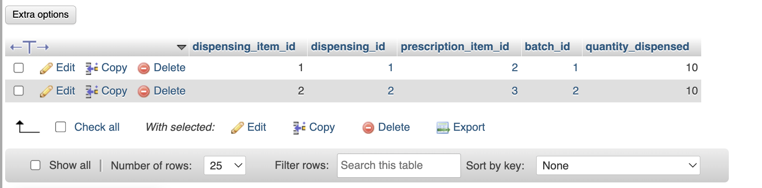
Stores the line-level stock details for each dispensing. A dispensing_item_id links to the parent dispensing_id and to a prescription_item_id, while batch_id identifies the exact medicine batch used and quantity_dispensed records how many units were supplied. The visible rows show quantities of 10 taken from batches 1 and 2. Capturing both the prescribed item and the batch provides traceability from the prescription through to the physical stock used for fulfillment.

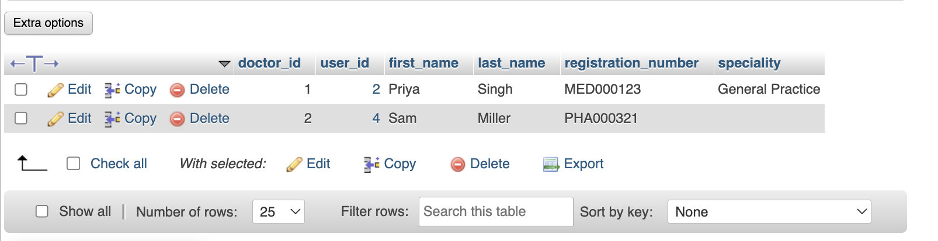
Stores doctor profile and professional identification information linked to the central user account. Each doctor record contains doctor_id, user_id, first_name, last_name, registration_number, and speciality. The visible entries include Priya Singh in General Practice and Sam Miller with a professional registration number. Keeping these fields separate from the users table allows authentication details to remain centralized while doctor-specific names, registration credentials, and clinical speciality are maintained in a dedicated profile.

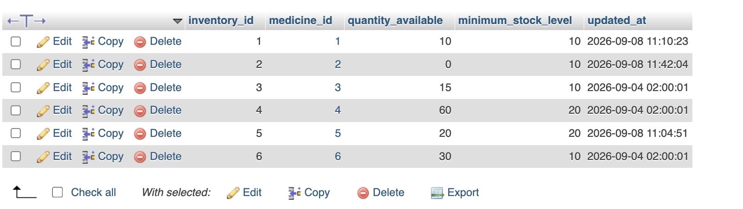
Maintains the central medicine inventory totals. Each inventory_id is linked to a medicine_id and records quantity_available, minimum_stock_level, and updated_at. The sample rows show different stock positions, including medicine 2 with zero units against a minimum level of 10 and other medicines at or above their thresholds. This gives the system a simple overall stock view and provides the values needed to identify low-stock or out-of-stock medicines.

Maintains detailed authenticated login sessions. Each login_session_id belongs to a user_id and stores a session_token_hash, role_name, ip_address, user_agent, login_at, last_activity_at, expires_at, logout_at, status, remember_me flag, and audit timestamps. The visible session is for a Patient role and is already Expired. Hashing the session token rather than storing the raw token supports safer session validation while the timestamps and client information allow session lifecycle and security activity to be tracked.

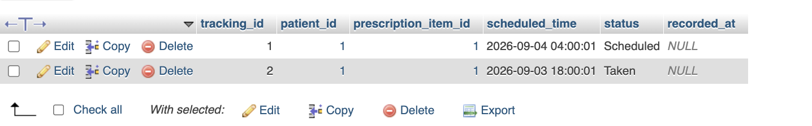
Tracks medication adherence against individual prescription items. Each tracking_id connects a patient_id to a prescription_item_id and records the scheduled_time, status, and recorded_at value. The sample records show one dose still Scheduled and another marked Taken. This structure allows the application to build a time-based medication schedule for a patient and retain the status of each planned dose, which can then be used for reminders or adherence history.

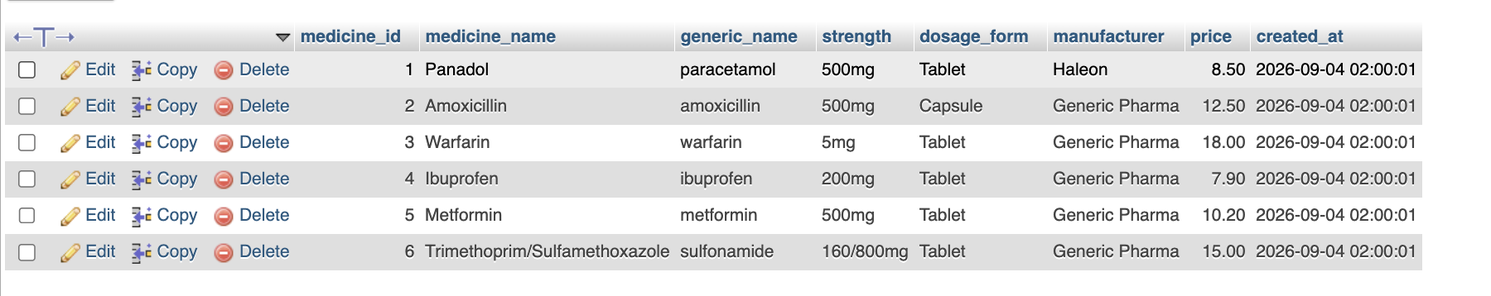
Serves as the master medicine catalogue. Each medicine_id stores a medicine_name, generic_name, strength, dosage_form, manufacturer, price, and created_at timestamp. The supplied records include Panadol/paracetamol, Amoxicillin/amoxicillin, Warfarin, Ibuprofen, Metformin, and Trimethoprim/Sulfamethoxazole. Centralizing these identifiers and product attributes gives prescriptions, inventory, batches, interaction checks, and shortage records a consistent medicine reference.

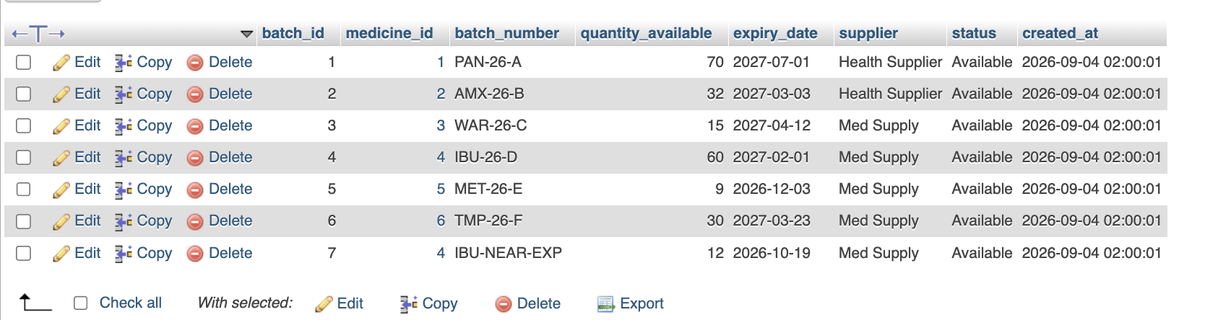
Provides batch-level medicine stock and expiry information. Every batch_id is tied to a medicine_id and contains a batch_number, quantity_available, expiry_date, supplier, status, and created_at. The visible batches are marked Available and include an Ibuprofen batch labelled IBU-NEAR-EXP with an earlier expiry date than the other stock. This structure supports lot traceability, supplier identification, expiry monitoring, and selection of an appropriate batch when medicine is dispensed.

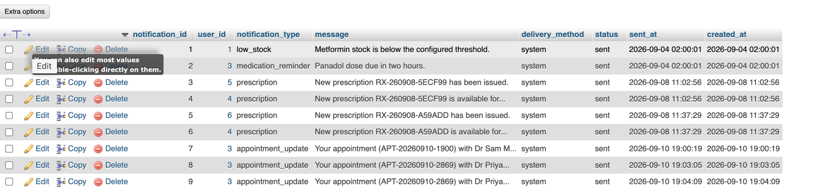
Stores system notifications sent to users. Each notification_id links to a user_id and classifies the message through notification_type, while message contains the notification text, delivery_method records how it was delivered, and status, sent_at, and created_at record its delivery state and timing. The visible examples include low-stock, medication-reminder, new-prescription, and appointment-update notifications, showing that the table supports both clinical and operational communications.

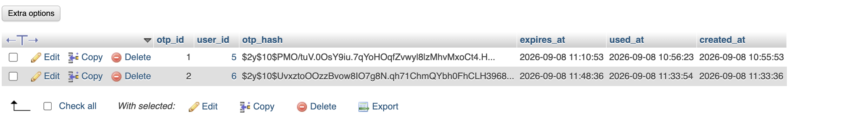
Supports one-time verification workflows. Each otp_id belongs to a user_id and stores an otp_hash rather than a plain verification code, together with expires_at, used_at, and created_at timestamps. The visible records show OTP entries that were used before their expiration times. The structure allows the application to validate short-lived verification attempts while retaining evidence that a token was consumed and preventing the original OTP value from being stored directly.

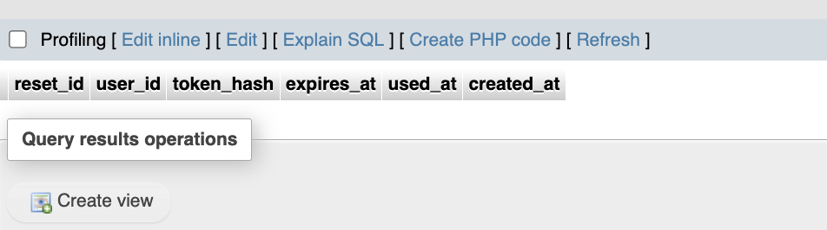
Supports password-recovery token management. The password_resets table contains reset_id, user_id, token_hash, expires_at, used_at, and created_at. The supplied screenshot currently contains no reset records, but the schema is designed to associate a hashed reset token with a user, limit it to an expiry window, and record whether and when it was used. This separates temporary account-recovery credentials from the permanent password hash stored in users.

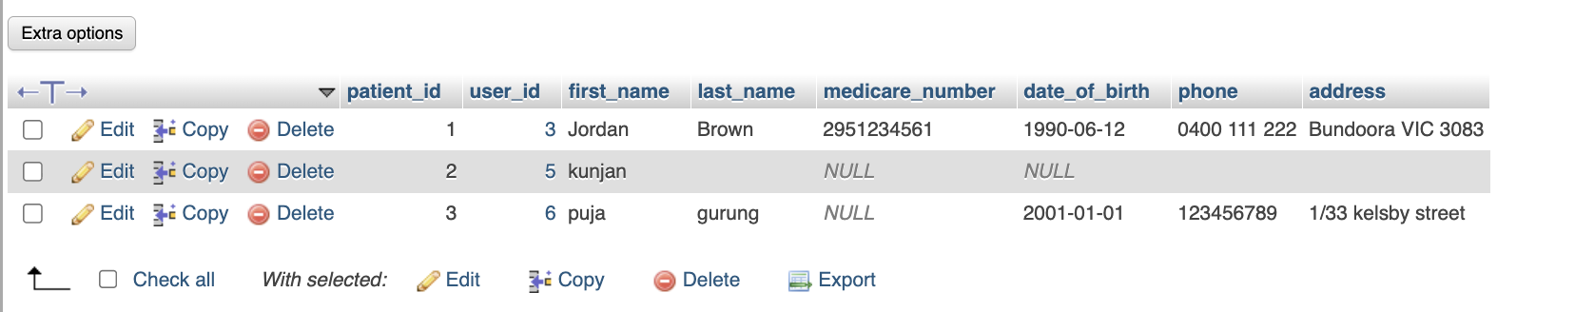
Stores patient profile and contact information linked to the central user identity. Each patient record includes patient_id, user_id, first_name, last_name, medicare_number, date_of_birth, phone, and address. The visible rows demonstrate that some fields can be NULL for newly created or partially completed profiles. This table gives clinical workflows a patient-specific record while login credentials and account status remain in the users table.

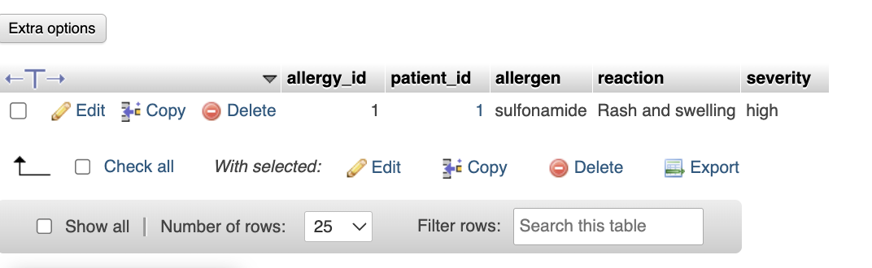
Acts as the patient allergy and adverse-reaction register. Each allergy_id belongs to a patient_id and records the allergen, the observed reaction, and severity. The visible record documents a high-severity sulfonamide allergy with rash and swelling. These fields provide the application with patient-specific safety information that can be checked alongside medicine interaction data before prescribing or dispensing medicines that may present a known allergy risk.

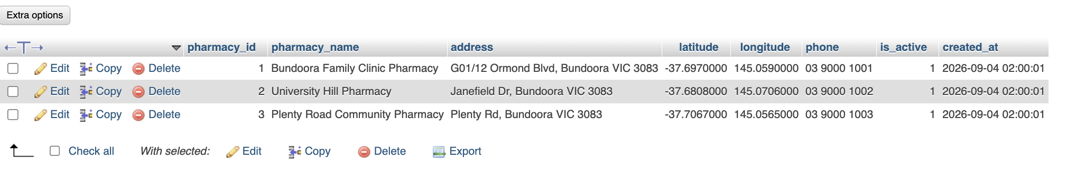
Catalogues pharmacy locations available in the system. Each pharmacy_id stores the pharmacy_name, address, latitude, longitude, phone, is_active flag, and created_at timestamp. The supplied data includes three pharmacies in Bundoora, each with coordinates and contact numbers. The geographic coordinates allow the application to work with location-based pharmacy selection, while is_active provides a simple way to exclude a branch that should no longer receive new activity.

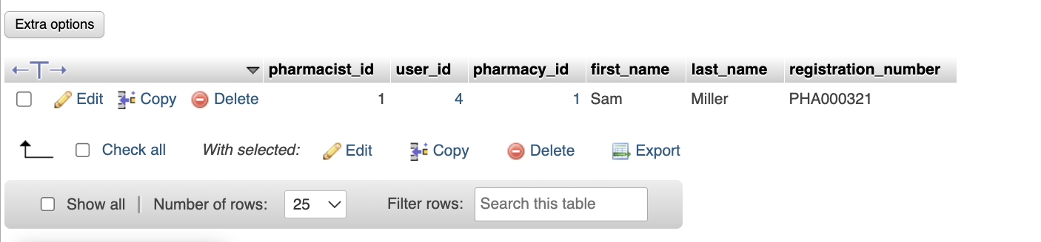
Stores pharmacist professional profiles and their branch assignment. Each pharmacist_id is linked to a central user_id and a pharmacy_id, and also records first_name, last_name, and registration_number. The visible record assigns Sam Miller to pharmacy 1 with registration number PHA000321. This structure connects authenticated pharmacist accounts to the exact pharmacy at which they are authorised to work and keeps pharmacist-specific registration information separate from general user credentials.

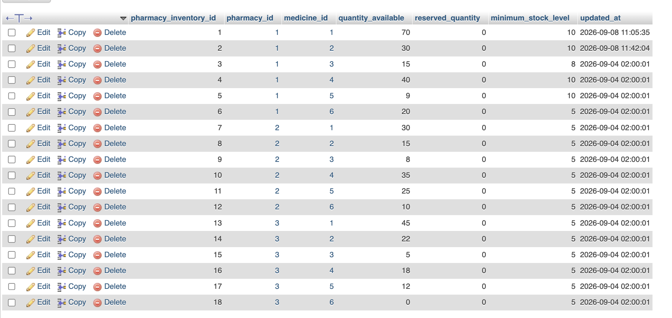
Tracks medicine stock separately for each pharmacy branch. Every pharmacy_inventory_id links a pharmacy_id and medicine_id and records quantity_available, reserved_quantity, minimum_stock_level, and updated_at. The 18 visible rows cover six medicines across three pharmacies, including low and zero stock situations. By separating available units from reserved units, the application can distinguish stock physically present from stock already committed to prescriptions and compare each branch against its own minimum stock level.

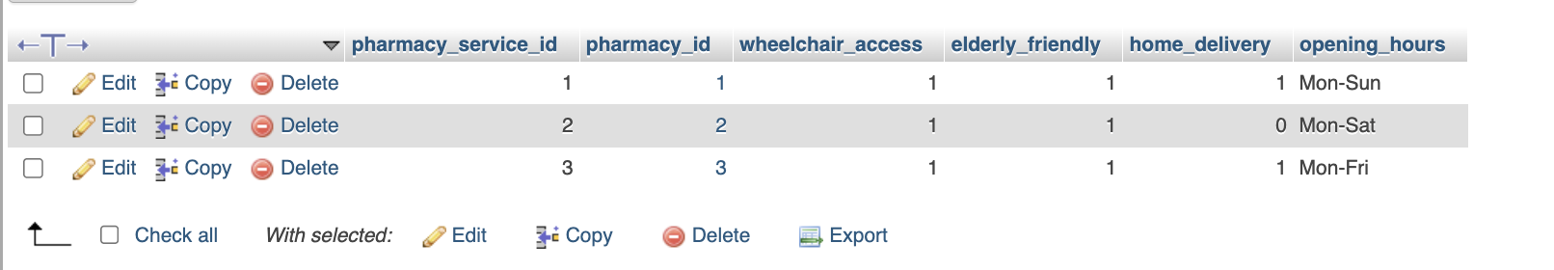
Stores branch-level pharmacy service and accessibility settings. Each pharmacy_service_id is linked to a pharmacy_id and records wheelchair_access, elderly_friendly, home_delivery, and opening_hours. The visible rows show all three pharmacies as wheelchair accessible and elderly friendly, while home delivery and opening days vary by branch. This compact structure allows patient-facing pharmacy selection to consider service capabilities and operating patterns in addition to stock availability and location.

Serves as the main electronic prescription header. Each prescription_id has a prescription_code and links a patient_id with a doctor_id, while prescribed_at and status record issuance and verification state. Sensitive diagnosis and clinical notes are stored in diagnosis_encrypted and clinical_notes_encrypted, and digital_signature plus created_at and updated_at support integrity and lifecycle tracking. The visible prescriptions are marked Verified, with encrypted clinical fields present on the newer records.

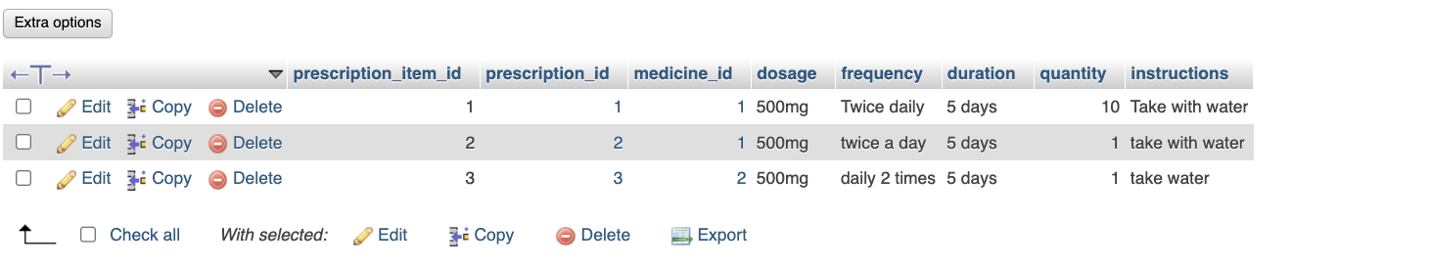
Contains the medication line items belonging to each prescription. Each prescription_item_id links to a prescription_id and medicine_id and records dosage, frequency, duration, quantity, and patient instructions. The visible examples include 500 mg courses with different frequency wording and five-day durations. Separating these rows from the prescription header allows one prescription to contain one or more medicine regimens while retaining the exact instructions and quantity required for each prescribed medicine.

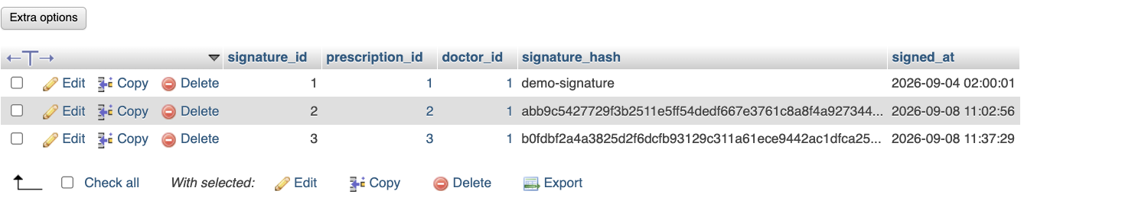
Stores prescription signature records separately from the prescription header. Each signature_id is linked to a prescription_id and doctor_id and contains a signature_hash and signed_at timestamp. The sample rows correspond to the three visible prescriptions and preserve a signature value for each. This provides a dedicated record showing which doctor signed a prescription, the stored signature digest, and the time at which the signature was applied.

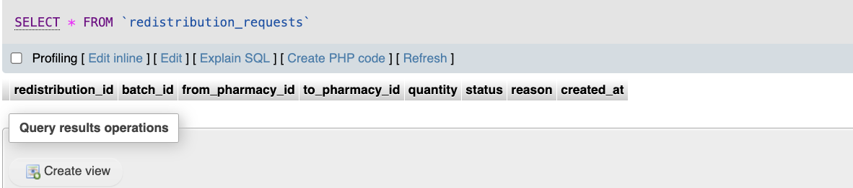
Supports pharmacy-to-pharmacy stock redistribution requests. The schema records redistribution_id, batch_id, from_pharmacy_id, to_pharmacy_id, quantity, status, reason, and created_at. The supplied screenshot currently shows no redistribution rows, but the fields allow a specific batch quantity to be moved from one pharmacy to another and the request to be tracked with a status and reason. Using batch_id also preserves lot-level traceability during a transfer.

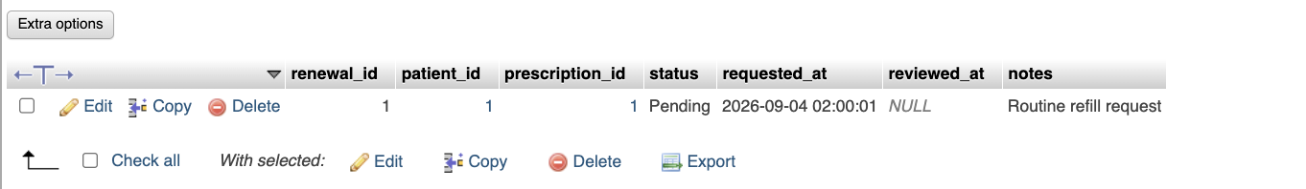
Stores patient prescription renewal requests. Each renewal_id links a patient_id and prescription_id, with status, requested_at, reviewed_at, and notes capturing the request lifecycle. The visible example is a Pending routine refill request whose reviewed_at field is still NULL. This structure allows a patient to request continuation of an existing prescription while keeping the original prescription reference and a clear audit trail of when the request was made and later reviewed.

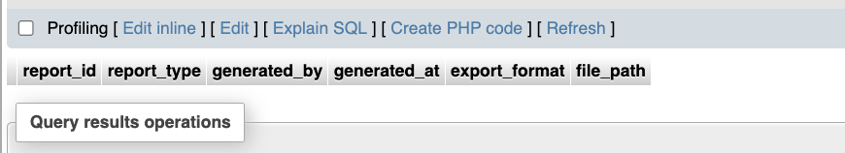
Provides a register for generated system reports. Its fields are report_id, report_type, generated_by, generated_at, export_format, and file_path. The current screenshot contains no report rows, but the schema supports recording what report was created, who generated it, when it was generated, the output format, and where the exported file was stored. This gives administrative reporting a persistent metadata record without storing the full report contents directly in the table.

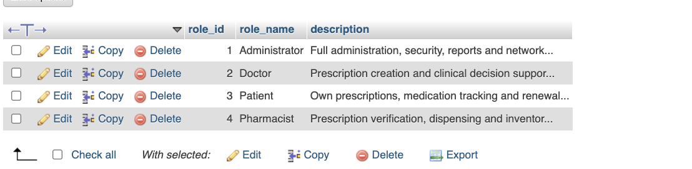
Defines the role catalogue used by the access-control model. Each role_id is paired with a role_name and description. The visible roles are Administrator, Doctor, Patient, and Pharmacist, with descriptions summarizing their responsibilities such as administration, prescribing, personal medication access, and prescription verification or dispensing. Keeping roles in a reference table allows account-to-role assignments to be handled consistently through the separate user_roles mapping table.

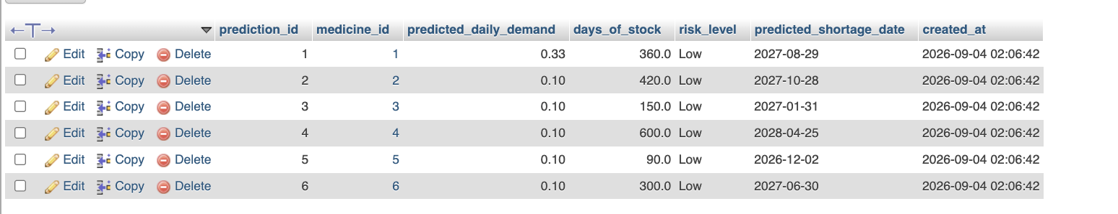
Stores medicine shortage forecasting results. Each prediction_id links to a medicine_id and records predicted_daily_demand, days_of_stock, risk_level, predicted_shortage_date, and created_at. The visible predictions are currently Low risk and estimate different remaining stock durations, from 90 days to 600 days. This table therefore captures the output of shortage calculations in a form that can be reviewed later and compared with current inventory or external shortage information.

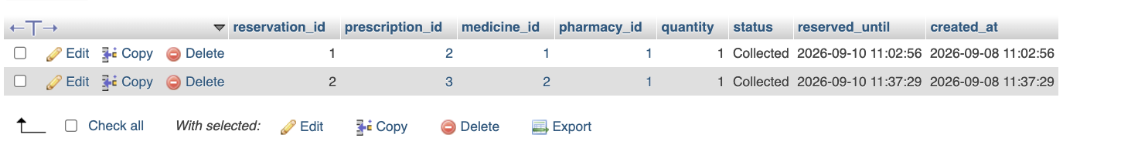
Handles temporary pharmacy stock reservations for prescriptions. Each reservation_id links a prescription_id, medicine_id, and pharmacy_id and stores the reserved quantity, reservation status, reserved_until deadline, and created_at timestamp. The visible reservations are marked Collected for two prescriptions at pharmacy 1. This allows stock to be committed to a particular prescription before final dispensing and provides a clear time and status record for the reservation lifecycle.

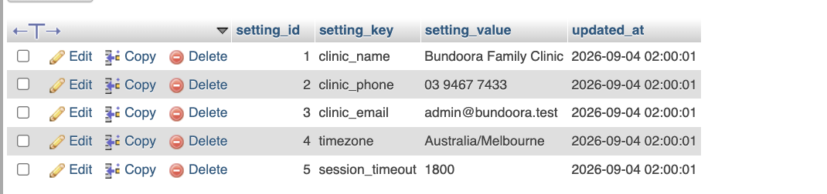
Stores application-wide configuration as key/value settings. Each row contains setting_id, setting_key, setting_value, and updated_at. The visible settings define the clinic name, phone number, email address, timezone, and session_timeout value. This design keeps operational configuration outside application code, making common values such as Australia/Melbourne timezone and the session timeout centrally available and independently updateable.

Records medicine shortage information associated with Australia's Therapeutic Goods Administration. Each tga_shortage_id links to a medicine_id and stores medicine_text, tga_reference, status, expected_resolution, source_url, and updated_at. The visible record identifies Amoxicillin 500mg as having Limited availability with reference DEMO-TGA-001 and an expected resolution date. This provides a structured place to connect external shortage notices with the internal medicine catalogue.

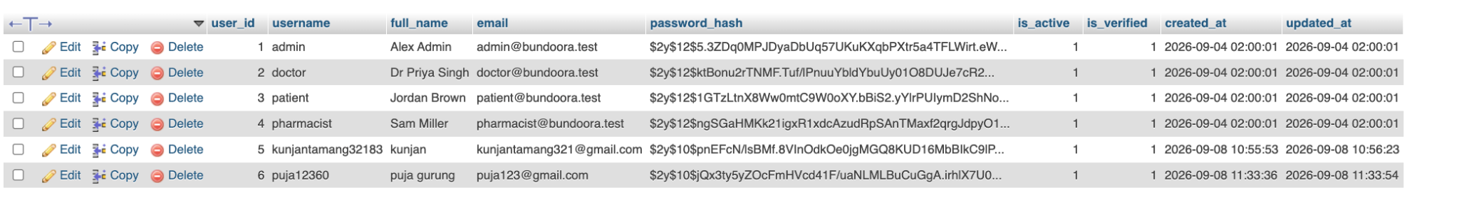
Serves as the central account and authentication table. Each user_id stores username, full_name, email, password_hash, is_active, is_verified, created_at, and updated_at. The supplied records include administrative, doctor, patient, pharmacist, and additional patient accounts. Passwords are represented by hashes rather than readable passwords, while the active and verified flags separate account availability and verification state. Role assignments are kept independently in user_roles rather than embedded directly in this table.

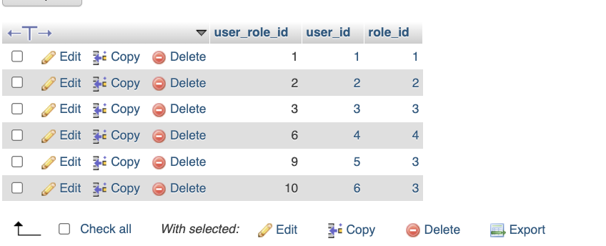
Maps user accounts to the role catalogue. Each user_role_id connects a user_id with a role_id, allowing authentication information in users to remain separate from authorization information in roles. The visible mappings assign the administrator, doctor, patient, and pharmacist accounts to their corresponding roles, with the two additional users also mapped to the Patient role. This junction-table design can support role-based access checks without duplicating role descriptions across individual user records.

Together, these 35 tables form an integrated database in which user identities and roles support clinical and pharmacy profiles; prescriptions connect to medicine items, signatures, reservations and dispensing; medicine stock is tracked centrally, by batch and by pharmacy; and safety, shortage, notification, session and audit tables provide the supporting controls required by the application.

